**Requirement Phase 1**

1. **User Expectations:** For the intended project, I interviewed some drone enthusiasts the get a view about their expectations for their next drone. They can be titled as the interested user for the product. With combining their ideas, I get the following features to be included in the drone:
   1. **Battery:** Battery provides the juice for flying a drone. A good drone should include a good capacity battery.
      * 1. **Good flight duration:** A normal drone available in the market has a flight time of 5 minutes to 30 minutes depending on the amount of money spent to buy it. A standard quality drone should have at least 15-20 minutes of aerial time, according to most drone users. Our clients expressed that a 20 minutes flight time sometimes leads to dissatisfaction. So, they expect the drone to have 3 times flight time of their current operational drones that is 1 hours of flight time.
        2. **Emergency battery:** There might be some emergency case when the battery doesn’t have enough charge to land the drone safely. The user would like a contingency plan for this situation. An emergency extension for battery life is expected from the drone.
   2. **Camera:** One of the most thriving elements for a drone. In most cases, camera of the drone is the main attraction for the device.
      * 1. **Stabilization:** Most of the clients think the camera as the most prioritized feature for their drone. So, they need a perfect camera for their product. A good camera is not a very difficult extension for them, their main expectation is the make the camera stable while flying. The wind and flight velocity make the camera to vibrate, resulting the video to be blurry in some cases.
        2. **Noise cancellation:** The propellers and motors of a daily used drone makes a lot of noise. This noise is recorded during shooting a aerial video. The user wants to reduce the noise as much as possible, either by a sound dampener attached with the propellers or a noise cancellation feature for the camera.
        3. **Rotatable:** Most drones in the market has a very rigid camera unable to change its angle of view. There are some companies which insert a 2-axial rotatable camera. But as days goes by, the demand for more realistic cinematography evolves. There are very few everyday use drones in the market having a 3-axial rotating camera.
        4. **Good frame rate:** The primary concern about a drone is camera most of the time. And this camera is mostly used for taking videos, not for snapping pictures. Most clients would always ask for a good frame rate for their drone camera. A 30fps camera can be set as a landmark for this aspect. While I interviewed some people, it was pretty obvious for most people to ask for 60fps or even better frame rate.
        5. **Good focusing properties:** Often the focusing is absent in a drone camera, but it exists sometimes. The users want a manually adjustable focus ranging from 0 to infinity, including automated feature, for the drone camera.
        6. **3D picturing:** The user wants to use the drone to make 3D images out of its recordings. Then that 3D picture can be used in a 3D printer to get a 3D model of any structure. This might reduce the time to draw a 3D diagram accurately on a sketching software, and with much more precision too.
        7. **Video streaming:** At modern age, live video streaming is a very popular platform, some travel-minded clients would like to use their drone to live stream an aerial video. This will take the camera to a new level.
   3. **Weather report:** When the drone is airborne, the user wants to have an on-screen detailed information about the current weather of the drone’s surroundings, for example temperature, wind speed and direction, humidity etc.
   4. **Terrain measurement:** The user has some certain specific interests for using the drone. They want to make detailed and precise maps using the drone. So, they are keen to add some hardware to measure the terrain below the drone. Terrain specification would include height, object definition, water sources, hills etc.
   5. **Modifiable propellers:** Some users look for independent control over the motors of each propeller. They expect the propeller position can be tilted up to some extent to ensure a smoother as well as convenient flight of the drone. The propellers will have some kind of lever to handle to speed, drifting, turning of the drone.
   6. **Flight:** After a drone is airborne, there are a few things that gives distinction to a drone of which range is very important.
      * 1. **Fair range:** Most drones in the market have a very small range of flight. The reason for this is that those devices are flown using Wi-fi connection. But a good drone has radio-frequency controlled flight system. The user wishes for a minimum of 1 km range of flight for the drone.
        2. **Auto-pilot feature:** The drone is expected to have a feature where the flight path is pre-assigned to the drone, and it follows that track by itself. This is similar to auto-pilot feature of a plane or ship.
        3. **First person view:** Some adventure loving users want to have the thrill of seeing the world from the top. They want to add an FPV feature which would enable them to view the drone’s view with the help of an FPV headset. It will generate a vibe of flying in the sky by themselves.
        4. **Voice control:** Now-a-days, many computerized systems include voice command features. Some highly ambitious users expect to add a voice controlled flying mechanism for the drone.

**Cost Estimation Phase 1**

After I came across several opinions of some interested users, I got a primary insight about the expectations of the random users, ranging from people who flies drone just as a hobby to people who are very knowledgeable and want to be a professional. I combined the expectations and requirements of all those enthusiasts in a nutshell. And then I figured out time, labor and financial estimation for the project.

1. **Required hardware parts to buy:**
   1. Flight Controller
   2. 3-axis Gimbal
   3. Camera
   4. Propeller X 6
   5. Motor X 6
   6. Speed Controller X 6
   7. Battery
   8. Hexagonal frame
   9. FPV camera
   10. FPV headset
   11. Controller
   12. GPS
   13. Weather sensors
       1. Temperature & humidity sensor
       2. Smoke sensor
       3. Carbon dioxide sensor
   14. Sonar
   15. Radio
   16. Necessary screw and other parts
2. **Cost estimation:** Any project, whether it’s based on hardware or software, has several matters to take under consideration to get an approximate target for the standard of the product.
   1. **Hardware cost:** The following table will show us the approximate cost estimation for the hardware parts we need to build our drone.

**Table 1:** Probable shipping cost included

|  |  |  |  |
| --- | --- | --- | --- |
| **Item** | | **Quantity** | **Approximate Price (US$)** |
| Flight controller | | 1 | 225 |
| Gimbal | | 1 | 150 |
| Camera | | 2 | 350 |
| Propeller | | 6 | 40 |
| Motor | | 18 | 450 |
| Speed controller | | 6 | 90 |
| Battery | | 1 | 30 |
| Frame (hexagonal) | | 1 | 50 |
| FPV camera & headset | | 1 | 100 |
| Controller | | 1 | 70 |
| GPS | | 1 | 40 |
| Weather Sensors | Temperature & humidity sensor | 1 | 10 |
| Smoke sensor | 1 | 20 |
| CO2 sensor | 1 | 12 |
| Sonar | | 1 | 120 |
| Radio | | 1 | 30 |
| Accessories | | As required | 25 |

* 1. **Time to finish the project:** The clients for a drone wishes to get the product as early as possible. They prefer to get hands-on experience rather than watching promotions for it. Apparently, a rapid prototyping is the way to satisfy the clients. But this type of drone is not a business purpose drone, rather it is a model made out of personal choices of features. So, rapid prototyping seems to be very expensive approach. And the drone contains a lot of delicate parts. So, the product once finished needs to be durable. A time length of 6 weeks seems to be quite humble for finishing this project. And the drone must be upgradable in future.
  2. **Labor cost estimation:** This project does not need a lot of people to participate. Even if we increase the man-power, the project is not likely to be finished sooner. Since this is not a business model, the involvement of the client and the only developer seems to be the best approach to adopt. Many developers might cause in clash of ideas and lead to complicacy, as we know each human brain works differently.

**Requirement Phase 2**

After drawing up the cost factors of the project, a meeting was held up with one client. Seeing the financial aspects, he expressed that the project is a bit overpriced to bear the cost. So, I had to start with the requirement phase again. But this time, I don’t have to start from the scratch. Because we only have to redraw the requirements of the hardware part, as these are the only things to make some amendments.

This time, my client and I together had a meeting, there we discussed about several hardware parts. This discussion lead to find out the primary concerns of the client. So, we could get rid of some less important features for the drone. But there is provision for developing those features in future. Let’s see what things were changed in that discussion.

1. **Battery:** It was expected that the drone should be able to fly for almost an entire hour. But it turns out that the battery for that capacity is quite heavy. And to lift that amount of weight, we need quite strong motors resulting into make several items of the drone pretty expensive. So, there were two options for the client: a) increase the budget, b) reduce the battery capacity. My client with the second choice. The battery capacity is changed to 40-45 minutes.
2. **Camera:** My client’s most important motive is to get a really good camera. So, he is not willing to make any changes for the camera features. But one thing that was very important at this discussion is that the client had several choices for the camera; different brands, different colors, different models and different price range. The client had an informative view of his choices and he got to choose his own desired camera.
3. **Propellers:** The clients in our first phase of interview hoped for a modifiable propeller structure. But as it turned out, for changing the orientations of the propellers, we need some extra motors in the segments of those wings. This would increase the cost as well as the vulnerability of the drone in the air. So, for now we decided the put this feature aside.
4. **Flight:** The flight features are almost unchanged. But the user has made a compromise about the voice controlled flying feature. He has put that feature as an optional one. Although the feature is not one of our primary concerns for this project, he still wishes to keep it as an option to develop in future. He also added another mode of flying the drone, a gesture controlled flying mechanism. But both of these are for further development, if the cost and time constraints doesn’t create problem at this moment.
5. **Special sensory features:** With the detailed consultation with the client, it turned out that the weather measurements are a little ambitious to add to the drone as they are not quite important for the client’s primary expectations. So, we cut short several sensors to be boarded on the drone. For now, only the temperature and humidity sensors are enough as expressed by the client. And a sonar is quite an expensive device and a suitable sonar for a drone is rather complicated and heavy for our project. So, the client had to get rid of the terrain measurement. But the map producing feature may be incorporated with some additional features with an additional piece of 360-degree camera if that can be arranged within the budget constraints.

**Cost Estimation Phase 2**

The 2nd phase of cost estimation was conducted almost at the same time as the 2nd phase of requirements. The user had a clear idea about the possible price range of several hardware parts. The only changes were made in the hardware cost. Time and labor cost remained the same as the 1st phase of cost estimation.

**Revised Hardware cost:** The following table mentions the primary requirements of the hardware components along with their possible financial cost.

1. **Table 2:** Probable shipping cost included

|  |  |  |
| --- | --- | --- |
| **Item** | **Quantity** | **Approximate Price (US$)** |
| Flight controller | 1 | 225 |
| Gimbal | 1 | 150 |
| Camera | 2 | 350 |
| Propeller | 6 | 40 |
| Motor | 6 | 150 |
| Speed controller | 6 | 90 |
| Battery | 1 | 30 |
| Frame (hexagonal) | 1 | 50 |
| FPV camera & headset | 1 | 100 |
| Controller | 1 | 70 |
| GPS | 1 | 40 |
| Temperature & humidity sensor | 1 | 10 |
| Radio | 1 | 30 |
| Accessories | As required | 25 |

The total hardware budget, after this phase of cost estimation, stands at a little more than 1360 US$. This budget stood at an astounding amount of more than 1800 US$ at our primary cost estimation. The removal of sonar and modifiable propeller has made the budget come down quite a great extent. This budget seems pretty acceptable to the client.

**Analysis Phase 1**

In this phase, I have determined exactly what will I be building. Starting with selecting the models of required hardware parts, I need to determine which hardware to be incorporated with which class along with the connectivity among the objects themselves. Necessary class diagrams of different types have evolved on multiple iterations along the process of development.

1. **User-case diagram:** This diagram will show all the classes of the project in a closed system and it will show the accessibility of different classes to various users and different objects.

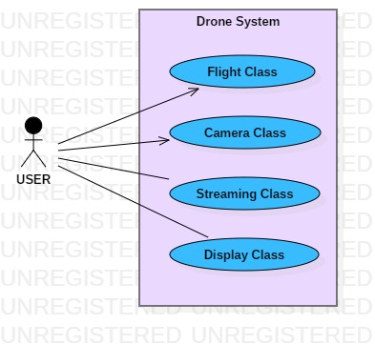

**FIGURE 1:**

Primary use-case diagram

Flight Class and Camera Class are accessible by the user. But Streaming Class and Display Class are not accessible directly.

1. **Class Diagram:** There are 3 different types of classes to represent a UML stereotype. These are, a. Entity Class, b. Boundary Class and c. Control Class. The class diagram for the primary class extraction is given below.
   1. **Flight Class**

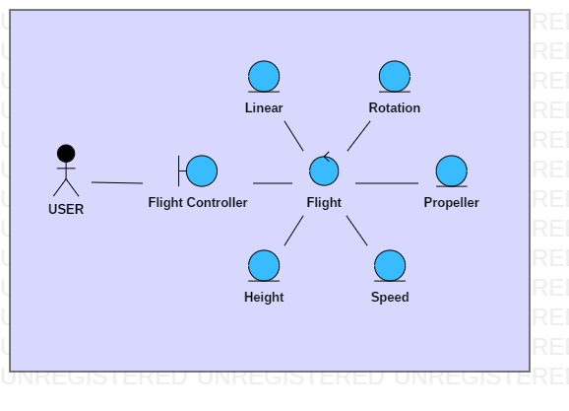

**FIGURE 2:**

Extended Flight Class in the Primary class diagram of drone.

* 1. **Camera Class**

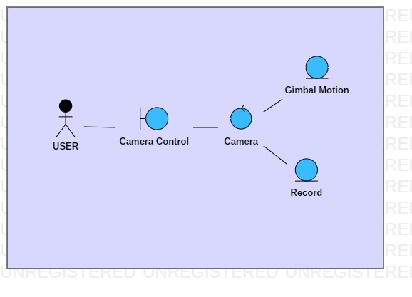

**FIGURE 3:**

Extended Camera Class in the Primary class diagram of drone.

* 1. **Streaming Class**

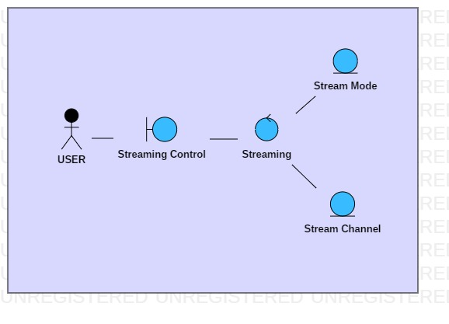

**FIGURE 4:**

Extended Streaming Class in the Primary class diagram of drone.

* 1. **Display Class**

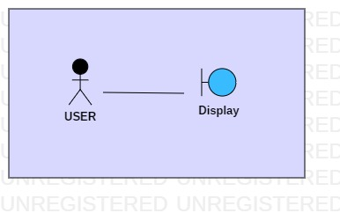

**FIGURE 5:**

Extended Display Class in the Primary class diagram of drone.

**Analysis Phase 2**

In this phase, a new class was included so that all other classes can be controlled more essentially. This class, named Remote control class, is used as a central class for all other classes. The user cannot directly access any other class other than Remote controller, but by the help of message passing method they can communicate with the help of several controller classes. Let’s see how it turns out in the following figures.

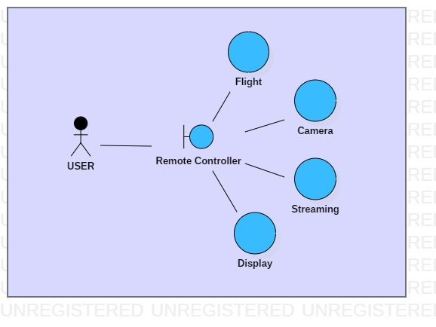

**FIGURE 6:**

Simplified Class diagram in the Analysis Phase 2

In Figure 7, it can be found that an extra class named Interface Controller is used as a boundary class. This class communicates directly with the Remote Controller class. The Remote Controller class acts almost as the central class of the whole class diagram. This class establishes all necessary communications between several classes with the method of message passing. Basically, here we can establish the Interface Controller class as the boundary class for the Remote Controller class. And Remote Controller class is obviously the main control class of the whole system.

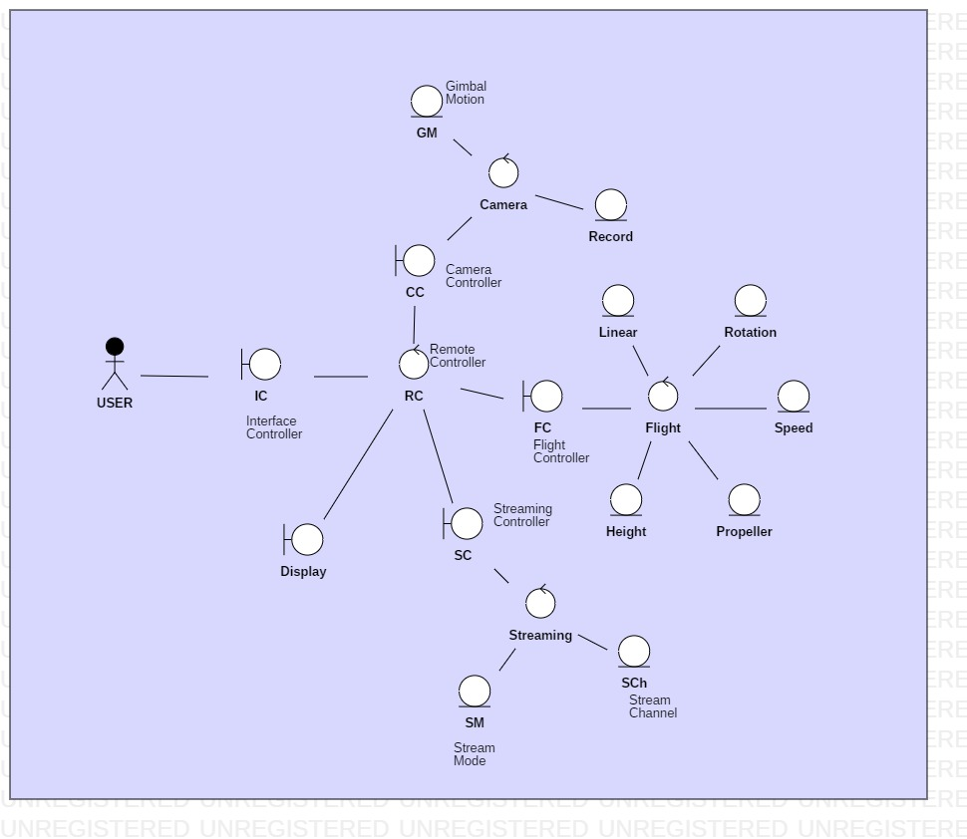

**FIGURE 7:** Extended Class diagram in the Analysis Phase 2

**Design Phase 1**

After getting a compatible class diagram from the analysis phase 2, I started working on the design workflow of my project. In this phase, my principal aim is to find out the detailed dataflow between several modules or classes or objects of the system. Basically, I have to build up the final class diagram in this phase so that in implementation phase, I can put the ideas obtained from the class diagram into codes.

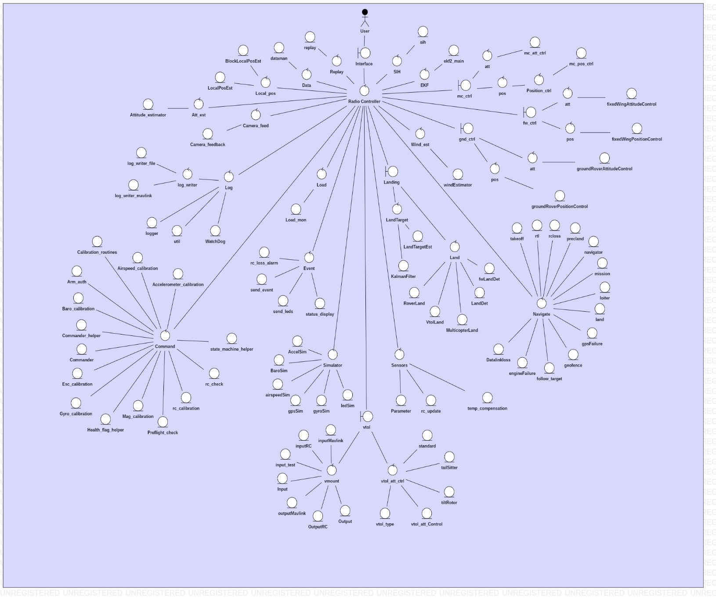

**FIGURE 8:** Detailed Class diagram of Design Phase 1.

Figure 8 shows an extended view of the class diagram extracted after the 1st Design phase. In the beginning of this phase, the base for me was the class diagram from the analysis phase 2, figure 7. But that class diagram seemed to be very inadequate from the point of view of flying the drone. I found out that the flying mechanism is way more complicated than that. So, I had to recreate the class diagram almost from the scratch. Except for the basic idea of handling the system smoothly with a central control mechanism, all other classes have been divided into so many other classes, and a lot of new classes evolved on that process. For example, I didn’t consider about the landing procedure of the drone. When I started with the Design phase, this matter became a very major thing in the system. There not a lot of boundary classes. The boundary class mainly affects the display of several information. The main boundary class is the Interface that is handled by the user directly. And all other control classes and entity classes accumulates all the information and sends them to the Remote Controller class, the central control class of the system. This class controls all the passage of messages in the binary form throughout the system. This class is built in into a Radio Controller which is used to fly the drone. The interface class is built into the display which we will use to output all the intended information. And the inputs will be made through the Radio Controller. Several sensors will have their own classes to operate with their own set of functions. These classes are usually found with the ordered parts of the commodities. And the rest of the classes to control the movement and actions of the drone will be installed into the flight controller.

The most important class in the class diagram of the system is likely to be the navigation class. This class controls most of the basic navigations of the drone. Basically, several buttons on our controller are different objects for different sub-classes of this superclass. All the navigation controls of the drone start with this class. Then moving along the dataflow, other classes gets involved in accomplishing the task requested.

As another significant class, the Command class can be noteworthy. This class measures the surroundings of the drone based on the readings on several sensors built in and attached to the craft, then it runs the system according to most suitable path to achieve maximum efficiency of the power. This class keeps the drone stable while airborne. The Command class solely does not have a physical counterpart to be assigned with, but it communicates with almost every other class to perform a safe and secured flight for our craft. This class is the brain of our drone system.

Right after discussing the hardware design part, the examples of several dataflow through the system will be described. There are so many operations to be finished, so all possible combinations of the dataflow cannot be presented here in details.

**Design Phase 2**

The prime concern regarding hardware section comes to the assembling of all the parts and carefully install all the classes into the illegible object. This way our system will be ready to be set on usage. The design has been made as modular as possible. During assembling the parts, I had to be very keen observer about the orientations of the propellers and the angular distances between the axial wings. Another important matter is the alignment of the landing gears and the wings. If the alignment is messed up, then the drone will not fly nicely, and soon it will drop and crash. The weight of several parts should be equally distributed over every quadrant. The balanced weight on each side is one of the most fundamental principles before flying a craft. So, every item of a specific thing should have the same origin as well as same weight and construct.

The follow up goes with the wiring of the hardware parts. Care should be taken so that no ware is hanging around the body of the drone, which might affect the flight of the drone. The cables should be properly connected to the specified ports. A malfunction in the waring may disable the power or some motors or any other part while the drone is airborne. In that case, the drone will be unable to operate and ultimately fall down on the ground.

The primary and most significant part of our drone is the flight controller, which needs to be placed at the center of the whole design so that all other parts of the craft can be easily incorporated with it. But while constructing the physical structure, first we need to build up the frame of the drone. My drone is a specialized hexa-copter with six propellers at the six corner points of the drone. The build of the frame allows it to be folded while offline into a slender long structure which makes it convenient for carriage. While building up the frame of the drone, we need to focus on the lengths of each wing. All the wings must have precisely equal length and weight.

On the outer edge of each wings, we will attach the motors and the propellers on the top of the motors. These are held together by the wings by some copper-made brush extensions. While attaching the motors and propellers, we need to focus on two things-

1. There are two kinds of motors, clockwise and anti-clockwise. We need to place them on the opposite wings to each other.
2. There are two kinds of propellers, we need to place similar ones on similar motors.

As we progress with our work after attaching the motors and the propellers to the frame, we need to focus on having a power source to gear up the motors so that the drone can fly. At this part, we need attach the battery at the middle. It needs to be put in a way that the balance of weight remains symmetric on every possible plane. Now the battery cannot fire automatically, so we need to give power connection with the flight controller. The power switch of the flight controller can be operated either remotely or by a manual switch. That takes power from the battery and distributes the power to all the motors and the drone becomes ready to fly.

Moving onwards, the movement of the drone depends on the rotation of its propellers. When all the propellers are rotating in the same speed, the drone remains steady. If the front two are slower than the back two, the drone moves forward and vice-versa. Similarly, the drone moves left and right. We see that something must control the rotation of the propellers i.e. the motors. That’s why we attach speed controllers to each motor. The other end of a speed controller is connected with the flight controller.

Camera is kind of an optional attachment for a drone. A camera is attached to a drone for flying the drone more comfortably at a long range. Attaching the gimbal to the frame comes before attaching the camera. There are ports for gimbal operation and camera control on the flight controller. The gimbal contains all those attachments. These are connected with caution and the gimbal is joined tightly with the frame. Then the camera is placed on the gimbal with some screws, and the camera controlling cables are connected to the camera from the gimbal. This way, the basic build of our drone is completed.

**Dataflow**

There are a lot of operations going on all the time in our drone system. Those operations all are combination of separate dataflows through the system. Theoretically, these dataflows have no reaction time where as in fact, there are some time lapse which affects the acceptance speed of a command when flying the drone. There are a huge number of dataflows in our system. Let’s have a look at some basic dataflows.

USER Interface Radio Controller Navigate takeoff Navigate

Radio Controller Interface USER

This is the takeoff dataflow for our system. The required data moves through different classes to achieve the expected operation. As we see, the operation starts from the user, hits takeoff class and then bounces back to user in a similar fashion as a boomerang i.e. the data goes from one point to another point, and then comes back to the initial point in the reverse way of its path. All the operations in our system works in a similar fashion. They start from the user, does the operation and then sends the feedback to the user. Some more basic dataflows are provided here.

USER Interface Radio Controller Navigate Land Navigate

Radio Controller Landing LandTarget LandTargetEst LandTarget

Landing Land MulticopterLand Landing Radio Controller

Interface USER

This dataflow describes the basic landing operation of our system. The landing operation is much more complex than the takeoff operation, yet have a much simple dataflow diagram. We find the basic use of the radio controller class here. It operates as the class to control the communication between several classes from the center.

Some accidents might happen at times, for example the battery power might run out when the drone is airborne. This drone has some contingency plan for that kind of events. It will raise an alarm and send the last location to the user so that he/she can go and find it. This is a very simple way of securing the drone in case of a very common accident that happens to many people.

USER Interface Radio Controller Events rc_alarm_loss Events

Radio Controller Simulator gpsSim Simulator Radio Controller

Events send_event Events send_led Events status_display

Events Radio Controller Interface USER

This dataflow shows the systematic way of raising the alarm when the battery runs out while the drone is airborne. This method will not send the exact location of the drone to the user, rather it will send a probable location since the last location it sends is not while the drone is on the ground. So, the drone can be found in about 25 meters radius circular area around that location as center. There are so many classes to visit in a specific sequence to handle the accident in a smooth way. This kind of contingency plans are what makes this project important on several aspects to build a next level drone.

**Final Purchases**

There are a lot of small hardware parts that are necessary to be bought to assemble together around the central frame so that our drone can be operational. In the cost estimation chapters, we have seen the basic names and a probable cost margin for most of these stuffs. Here, we are going to see the exact models and required price for buying those hardware parts including a brief information about the features. Let’s have a look at it.

**Table 3:** Purchased hardware parts necessary for constructing the drone.

|  |  |  |  |
| --- | --- | --- | --- |
| **Item** | **Specification** | **Qty** | **Total**  **(RMB)** |
| Tarot T810 Frame | Hexa-copter frame with propellers included,  Carbon fiber axes and the central frame skeleton,  2 fixed axes and 4 moveable axes by 60 degrees | 1 | 290.00 |
| Tarot T810 Gimbal kit | 3 axial movement,  Carbon fiber build,  Standard DSLR holding pin with space to adjust one full sized DSLR | 1 | 615.00 |
| Hao-ying motors | ESC included,  240-280C power output,  3 clockwise and 3 anti-clockwise | 6 | 1220.00 |
| PIXHAWK Obstacle detection sensors | One detects the presence of any obstacle on the trajectory, another changes course accordingly | 2 | 105.00 |
| PIXHAWK RGB LED | 3 colors- Red, Green and Blue,  Determines different modes while active | 1 | 32.00 |
| UBIox M8N GPS | Transmits the location live,  Accurate by 15 feet | 1 | 168.00 |
| Tarot T810 Battery | 12000 mAh power,  Fast Charge capability,  Lasts for 30-35 minutes | 2 | 700.00 |
| PIXHAWK APM Flight Controller | 12 ports max,  Programmable | 1 | 238.00 |
| APM Power supply module | Can adjust a full-sized battery,  3 power connection ports | 1 | 38.00 |
| Jumper T16 Controller | Includes a set of batteries for the controller,  Full HD LCD display, 2.4GHz Telemetry,  Built-in speakers, 16 independent broadcast channels | 1 | 1039.00 |
| GoPro Hero 7  Black Edition | 4K quality action camera,  7 hours of battery life,  Zoom disabled | 1 | 2590.00 |
| 3DR Radio Telemetry kit 433 | Telemetry range 1000 meters approximately,  Signal accuracy 92.3% | 1 | 185.00 |

I had to buy most of these parts after finishing the final design. Moreover, sometimes there were defective hardware after the products were delivered to me. It needed quite a while to gather all necessary parts together and start working on the assembling part of the project.

**Prologue**

There are a lot of shortcomings for our project at this point of time. A lot of factors worked behind this outcome. This is the first practical work for me. So, there were a lot of times when I lost the flow of work, I was confused about the better option. I had to iterate a lot throughout the project completion period. There had been a lot of changes for the plans over different phases. Sometimes very simple matters were overlooked and as a result, I had to fall back to some phase and develop that part. With time and experience, the number of defects on my work will be reduced.

Let’s look at the accomplishments over time while developing this project. At this project, I have learnt to incorporate software with hardware. The modern world runs depending on this matter. Every part of our drone has been a result of successful incorporation of software with necessary hardware. One could not work without the other. I have used several programming languages for achieving a good software for our project, for example Java, C++, C, Python etc. The software has been developed with the help of some open source programs. I have collected several open source programs for several parts of the drone. Then I made necessary changes that I thought to be suitable for our drone. Finally, I got a software ready to be installed into the system of the drone.

The hardware parts are not the very best ones available in the market right now. But all the parts are welly compatible with those best products. The tests have shown good output too. And the main advantage of my project is the modularity of the drone. In future, the maintenance will be much easier. We can upgrade any part only by replacing the class for that specific module, or enhancing the hardware counterpart. We can also upgrade the drone by adding several hardware along with the installment of required software. The motors we bought are very powerful and efficient to lift a good amount of weight in the air. And most of the adjustments in the future will not cause a big increase in the weight.

The gimbal we have is not very suitable to carry light weight cameras. But the advantage of this gimbal is that it is highly modular. It can be easily replaced with another gimbal. In future, I want to use an action camera of very small size, that will also reduce the net weight of the drone by a lot. And I can increase the functionality of the drone after doing that by adding some very delicate hardware with it. The drone I built may not be very suitable for marketing since most people doesn’t want a drone with so many applications. Those who want that many functionalities usually make it by themselves. But the main objective of my project was to build a highly efficient multi-functional super drone. And I believe I have been successful on building the 1st version of this drone. I intend to further develop this project of mine. Here, I have included some points that I want to work in the maintenance phase of this product.

1. Refueling while the drone is airborne.
2. Adjustment of different parts of the drone according to the weather and surrounding environment.
3. Fancy flight mode and styles.
4. Adjustable hands to lift things and deliver it at certain place.
5. Ability to read address and find a current best way to reach somewhere.
6. Improved AI to take images by itself.
7. Enhanced visual aids for the camera.
8. Improved FPV to enhance the first-person perspective and experience of the user.
9. Creating 3D mapping system with inclusion of necessary hardware and software.
10. Fix a specific target object and following the target.

These are the focus points for the maintenance phase of my project. I look forward to make the drone work with an AI monitored system and a structural build with nanotechnology. In future, I want to developed this drone into a super-drone, and consequently a mega-drone.